Functions

Video 1,
Popper 04

Increasing/decreasing graphs
Basic Graphs Worksheets
Linear
Quadratic
Cubic
Cube Root
Square Root
Absolute Value
Exponential
Logarithmic

Video 2,
Popper 05

Rational Functions

Video 3,
Popper 06

Polynomials
End behavior
x-intercepts and behavior at them
Working backwards

Sequences
Notation
Domain and Range
Bounded Sequences

Appendices
Interval Notation
Factoring – The Guaranteed Method
Complete the Square Method
Factoring by Grouping

In this module,

we will be looking more deeply at functions – in particular, the graphs of functions.

Starting off with 3 important properties which describe the behavior of the graph, we’ll define” increasing, decreasing, and neither” and see how certain graphs exhibit these properties. Then we’ll review of various families of graphs – lots of types of functions, all except rational functions and polynomials

We’ll look at only rational functions in the second video and only polynomials in the third video. These types of functions are so important that they each get a separate video!

Increasing and decreasing graphs

We often talk of a turn-around point, a place where a graph “changes direction”…so it is important to be able to talk about what is happening at a turnaround point. Most graphs can be described as increasing, decreasing or neither…and knowing where the graph is exhibiting these properties helps us understand the behavior that the graph represents.

Let’s look at a graph that has all three movements to get an intuitive sense of the descriptions:

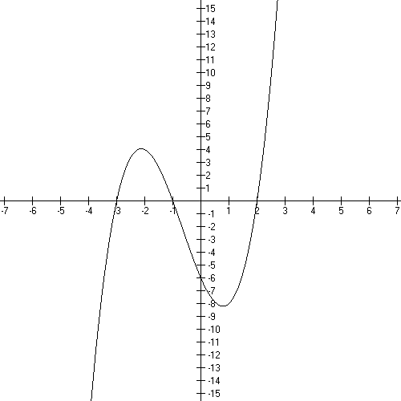

Domain

Range

Intercepts

Increasing

Decreasing

Neither

An application of the concept:

If you graph a revenue function for a retail item, the most common shape is a cupped down parabola. Now, firms are always wanting to increase revenue. Let’s look at how increasing/decreasing/neither would work to alert a manager of what to do to keep the revenues flowing in.

We have months on the x-axis and dollars on the y- axis here.

First off, why is revenue cupped down?
And what do the parts of the graph below the x-axis mean?

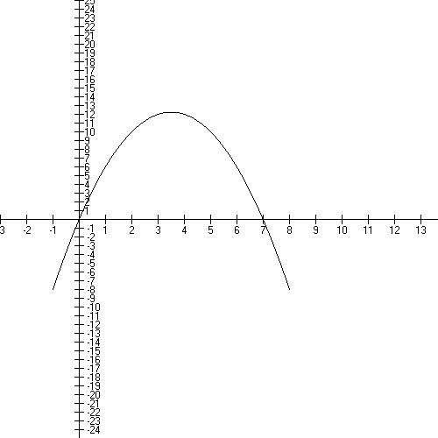
Where is the graph incr, decr, and n?

Secondly:
When is the BEST time to have a sale?

Identifying exactly WHICH x is the x of the turn-around point is a focus of this class. We will learn how to do this in the Derivatives section.

We can identify “increasing” and “decreasing” on a graph and note that “neither” occurs at a turn-around point (or if the graph is a flat horizontal line).

We always do this in a certain way. First we look at the x’s and we scan the axis from left to right. Note that the smaller x’s are on the left. In fact, if we number a first x and a second x moving left to right, we have:
.

Then we check the motion of the y values on the y axis as the x’s get larger and larger. So identifying the relevant property is a sort of scanning process.

If the y values are moving UP the y axis as they get used, then the function is increasing. If the y values are moving DOWN the y axis as they get used, then the function is decreasing.

This has nothing to do with the sign of the y value – a graph can be in Quadrant 3 with negative numbers for x and y and still be increasing (see the first example below).

For example: Here is the graph of y = 0.5x − 6

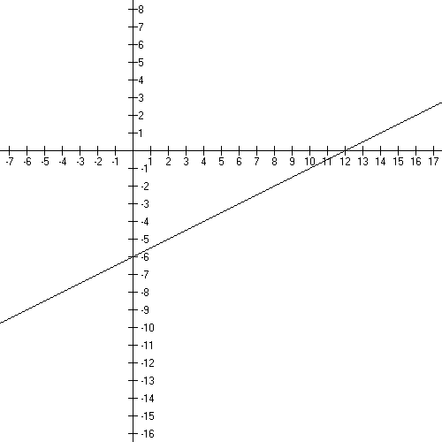
Domain

Range

Intercepts

Increasing

Decreasing

Turn-around points:

This graph of a line is increasing everywhere on its domain…even in Quadrant 3 and Quadrant 4 where the y’s are negative numbers.

Another example:

Here is the graph of $f(x)=−x^{2}$. What are the domain, range, and intercepts? Where is the graph increasing, decreasing, or neither?

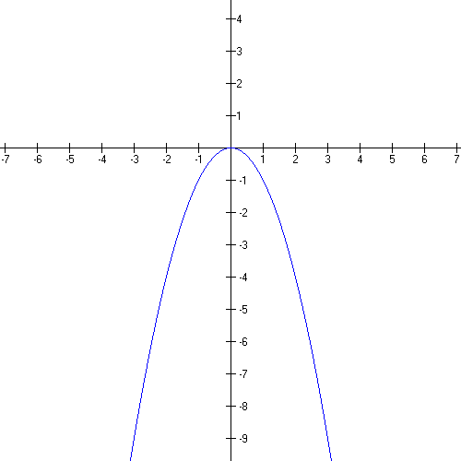
Domain

Range

Intercepts

Increasing

Decreasing

Turnaround point:

Note that you always specify where a graph is increasing or decreasing on intervals of the x axis, even though you’re talking about the behavior of the y values!

Here is the graph of $f(x)={\text{10}}^{x}$, an exponential graph. The domain is all real numbers and the range is . Note the leftward half-asymptote, too!
Are there any turn-around points?

Let’s trace out how we know it’s increasing on its domain:

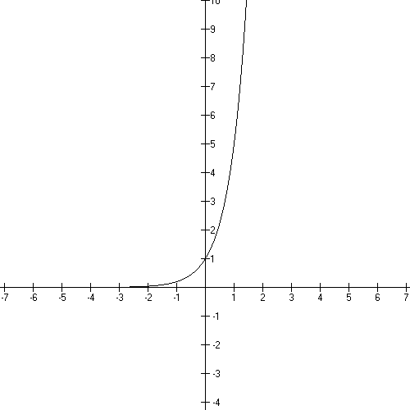

Here’s a polynomial. The domain and range are each all real numbers.
What is the formula for this polynomial and how would you know?

Where is the graph increasing?

Decreasing?

Neither?

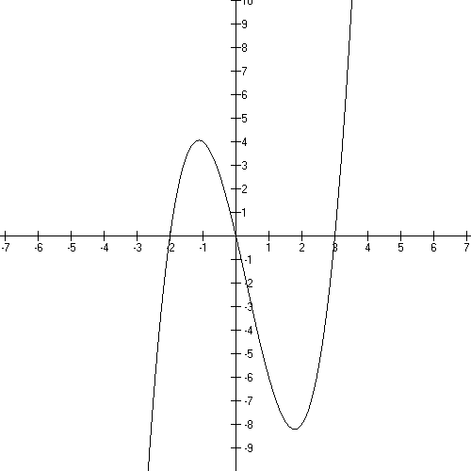

Basic Graphs Worksheets

Here we’ll look at various families of graphs, always starting with the basic or “parent” graph and then looking at a couple of shifted graphs. We’ll review the function facts like domain, range, and intercepts along with discussing increasing/decreasing/neither for each family.

For an excellent review of graph shifting, check out the videos in the UH Math 1310 textbook for College Algebra:

http://online.math.uh.edu/Math1310/

Look for Chapter 3, Section 4 on transforming graphs.

While you’re there you might check around for any other topics you want a review on…the videos are just excellent!

Basic Linear Function:

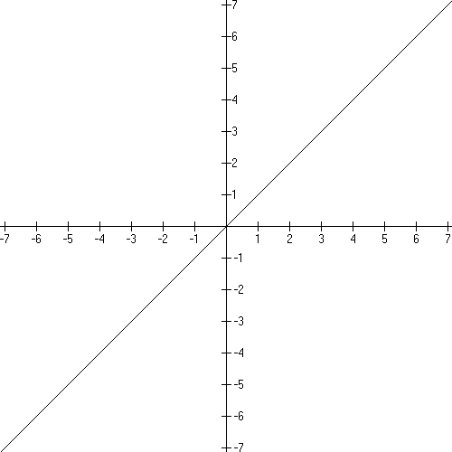

Domain:
Range:
x intercept: (0, 0)
y intercept: (0, 0)

Increasing everywhere.

This function is one-to-one.

f(x) =

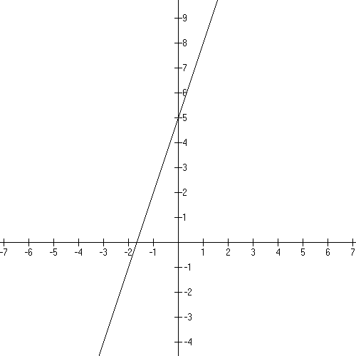
Domain:
Range:
x intercept: (−5/3, 0)
y intercept: (0, 5)

Increasing on its domain!

Telling what’s happening depends on the slope, m, of the line. Let’s see how

m = 0

Intercepts:

Neither!

m > 0

Intercepts:

Increasing on its domain!

m < 0

Intercepts:

Decreasing on its domain!

Graph below for demo! Let’s trace out the
x and y movements on the axis to help see the “decreasing” description

Popper 04, Question 1

Basic Quadratic function:

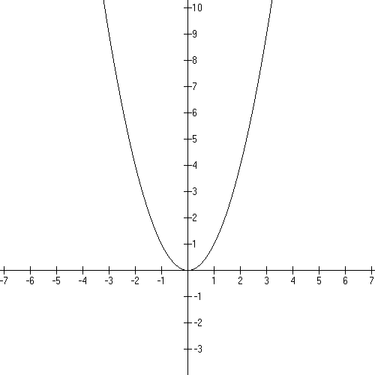
Domain:
Range:
x intercept: (0, 0)
y intercept: (0, 0)

Decreasing:
Increasing:

Neither at (0, 0), the turn-around point

This function is not one-to-one.

Example of a shifted graph:

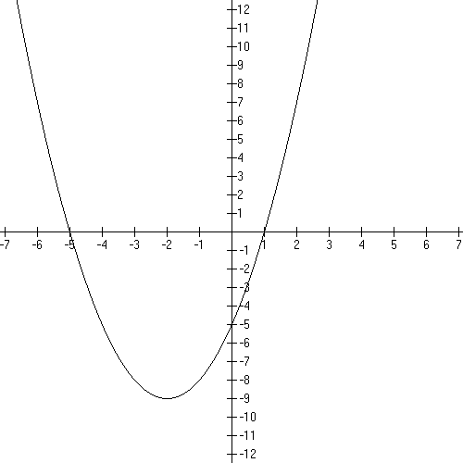

Domain:
Range:
x intercepts: (−5, 0) and (1, 0)
y intercept: (0, −5)

vertex: (−2, −9), the turn around point!

decreasing $(−∞,−2)$
increasing $(−2,∞)$

neither at the vertex!

Let’s work out a whole problem here, reviewing as we go.
Here’s the graph of a nice cupped-up parabola

Where are the intercepts on the graph? What are the point coordinates for the intercepts?

x-intercepts?

y-intercept?

What do the x-intercepts tell us?
What is the formula?

Let’s multiply that formula out and then find the vertex using algebra and see if it looks right where the graph has it.

Now, where is the graph increasing, decreasing, or doing neither?
Report your answer in interval notation.

Popper 04, Question 2

Basic Cubic function:

$$f(x)=x^{3}$$
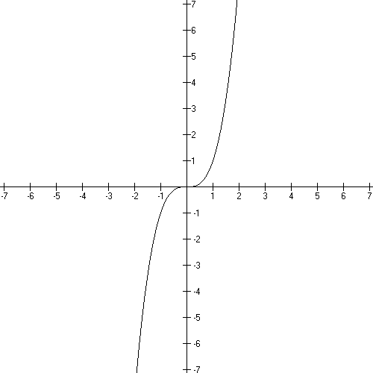
Domain: $(−∞,∞)$
Range: $(−∞,∞)$
x intercept: (0, 0)
y intercept: (0, 0)

Increasing everywhere.

This function is one-to-one.

Example of a shifted graph: $f(x)=\frac{1}{2}(x−1)^{3}$

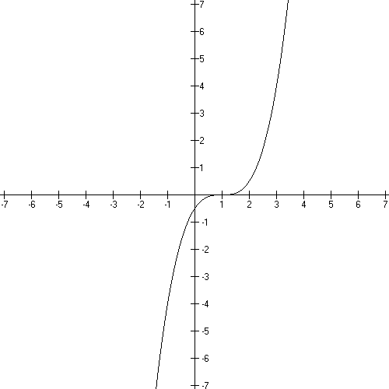
Domain: $(−∞,∞)$
Range: $(−∞,∞)$

x intercept: (1, 0)
y intercept: (0, −1/2)

no turn around points,
increasing on its domain

Let’s look at a cubic with a HUGE change:

How are we going to handle this? We need to graph it.

Let’s get the intercepts:

is the y-intercept:

To get the x-intercept(s), solve for x.

And let’s get a few points

f(1) = f(2) =

f(−1) = f(−2) =

[Let’s try to remember graph shifting from College Algebra – a negative sign in front of the formula means a reflection about the x-axis.]

Let’s graph what we’ve got so far

So, now let’s analyze it by working with the process that helps us identify whether the graph is increasing or decreasing:

Taking the x’s left to right….

Are there any turnaround points? No? well then the graph will be doing the same thing on it’s whole domain….

So –f(x) means a reflection about the x-axis! Watch for those.
We saw one earlier with…let’s review that graph on page 7!

Popper 04, Question 3

Basic Cube Root function:

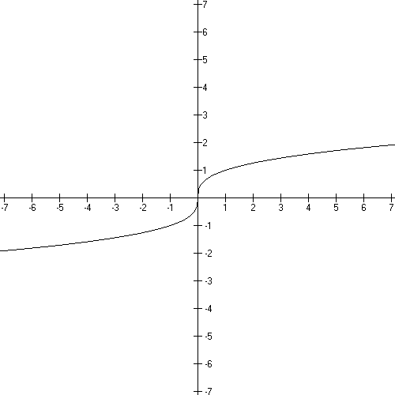
$$f(x)=\sqrt[3]{x}=x^{\frac{1}{3}}$$

Domain: $(−∞,∞)$
Range: $(−∞,∞)$
x intercept: (0, 0)
y intercept: (0, 0)

Increasing everywhere.

This function is one-to-one.

Example of a shifted graph: f(x + 1) − 2

- shifting instructions: left 1, down 2

- new formula: $f(x)=(x+1)^{\frac{1}{3}}−2$

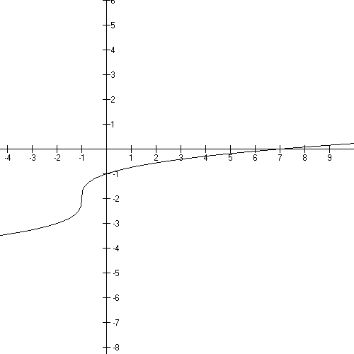

Domain: $(−∞,∞)$
Range: $(−∞,∞)$
x intercept: (7, 0)
y intercept: (0, −1)

increasing everywhere

track the key point (0, 0) to (−1, −2)

Example:

Graph $f(x)=−x^{\frac{1}{3}}$. Where is the graph increasing or decreasing?

The domain is all real numbers and so is the range.
The negative sign means to reflect about the x-axis.

Here’s the “parent graph: $f(x)=\sqrt[3]{x}=x^{\frac{1}{3}}$. Let’s do the reflection:

Popper 04, Question 4

Basic Square Root function:

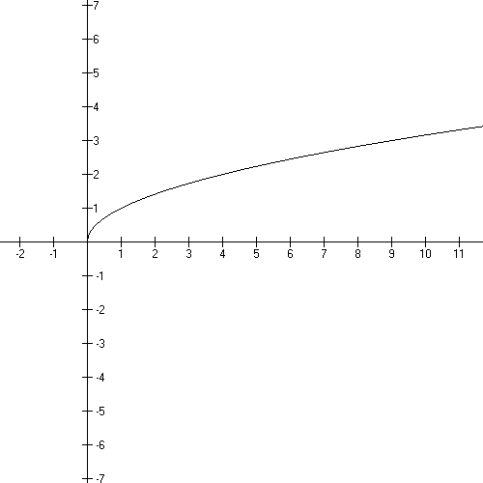
$$f(x)=\sqrt{x}=x^{\frac{1}{2}}$$

Domain:
Range: $[0,∞)$
x intercept: (0, 0)
y intercept: (0, 0)

Increasing on its domain.

This function is one-to-one.

*Domain restriction!

Example of a shifted graph:

- shifting instructions: reflect about the x axis,
left 3,
reflect about the y axis

- new formula: $f(x)=−\sqrt{3−x}$

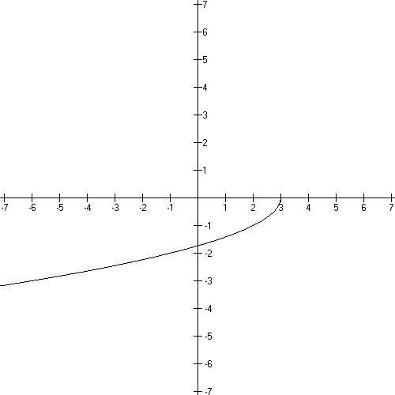

Domain*: $(−∞,3]$
Range: $[0,∞)$
x intercept: (3, 0)
y intercept: $(0\text{.}−\sqrt{3} )$

increasing on it’s domain
note the signs on the y’s
Examples:

Graph $f(x)=\sqrt{9−x}$. Where are the intercepts? What is the domain and range?
Where is the graph increasing or decreasing?

Graph $f(x)=(x+4)^{\frac{1}{2}}$. Where are the intercepts? What is the domain and range?
Where is the graph increasing or decreasing?

Popper 04, Question 5

Basic Absolute Value function:

$$f(x)=\left| x \right|$$
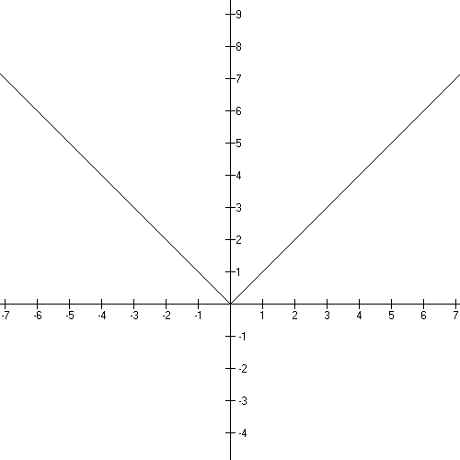
Domain: $(−∞,∞)$
Range: $[0,∞)$
x intercept: (0, 0)
y intercept: (0, 0)

Decreasing:
Increasing:

This function is not one-to-one.

Example of a shifted graph: −f(x − 5) +2

- shifting instructions: reflect about the x axis,
right 5, up 2

- new formula: $f(x)=−\left| x−5 \right|+2$

Domain: $(−∞,∞)$
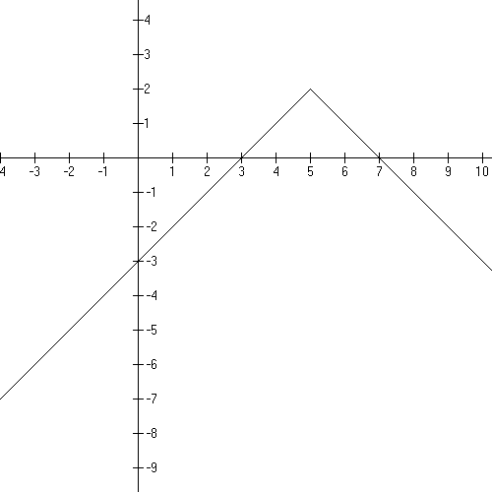
Range: $(−∞,2]$
x intercepts: (7, 0) and (3, 0)
y intercept: (0, −3)

increasing $(−∞,5)$
decreasing $(5,∞)$

Examples:

Where is the following function increasing and decreasing?.

$$f(x)=\left| x+3 \right|−2$$

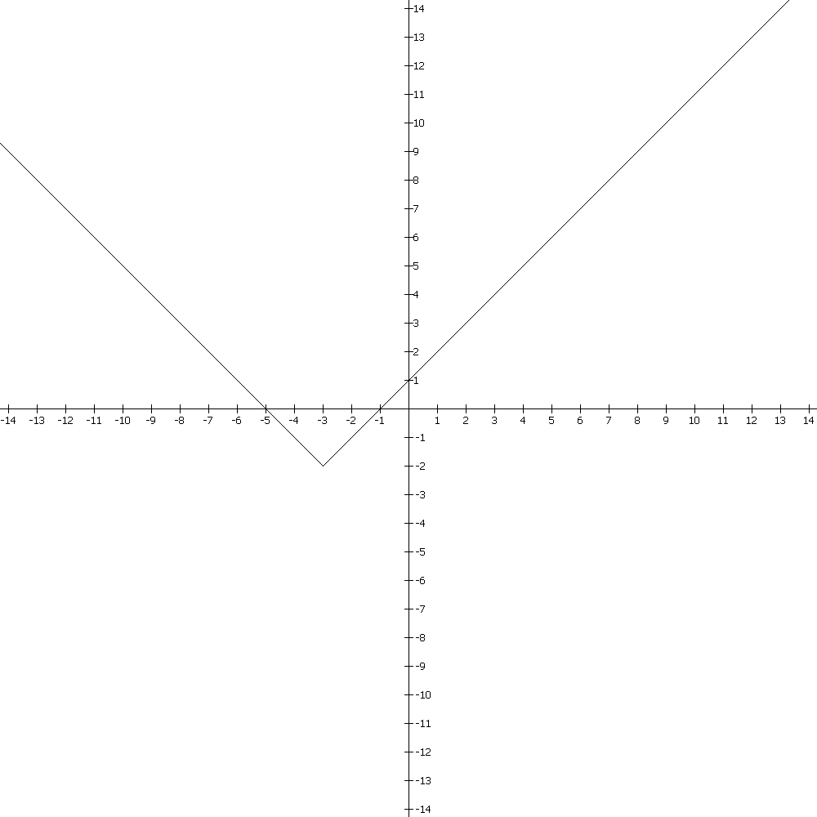
Increasing/decreasing/neither

One to one?

Graph

Discuss increasing/decreasing/neither
Popper 04, Question 6

Basic exponential function:

Domain: $(−∞,∞)$
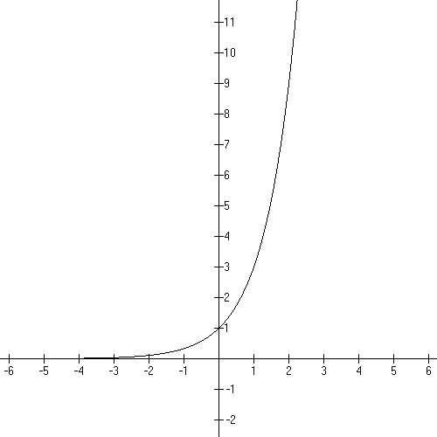
Range:
x intercept: none
y intercept: (0, 1)
horizontal asymptote: y = 0

Increasing everywhere.

(the illustration is with b = 3
see the point (1, 3))

Example of a shifted graph:

- shifting instructions: reflect about the x axis,
left 3, up 9,

- new formula:

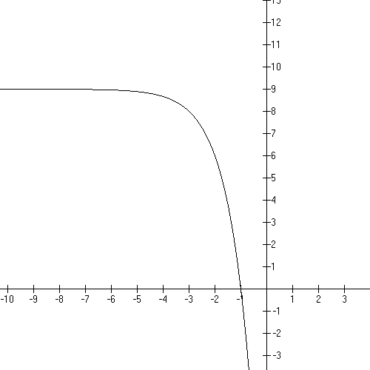

Domain: $(−∞,∞)$
Range:
x intercept: (−1, 0)
y intercept: (0, −18)
horizontal asymptote: y = 9

decreasing everywhere.

Examples

Tell me everything about: $f(x)=3^{x}−9$

Popper 04, Question 7

Basic logarithmic function:

$$f(x)={\text{log}}_{b}(x)$$
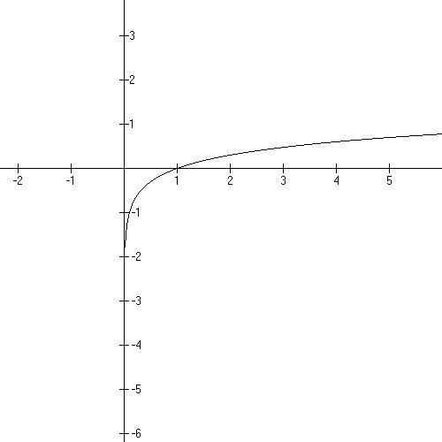
Domain:
Range:
x intercept: (0, 1)
y intercept: none

Vertical asymptote: x = 0

Increasing on its domain.

This function is 1:1.

(illustration is with b = 10)

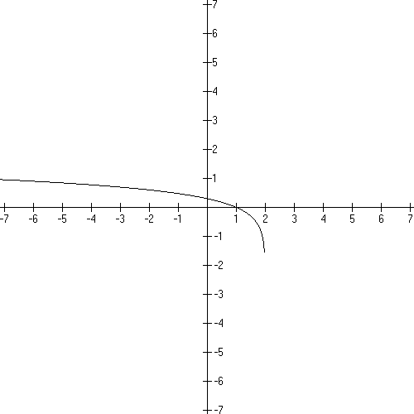

Example of a shifted graph:

- shifting instructions: left 2, reflect y

- new formula:

Domain: Domain Restriction!
Range:
x intercept: (1, 0)
y intercept:

vertical asymptote: x = 2
decreasing on its domain

Basic Logarithmic Review:
Example:
Tell me everything about $f(x)={\text{log}}_{3}(x+9)$

Popper 04, Question 8

Popper 04, Question 9

Popper 04, Question 10

End Video 1
Functions – Video 2

Rational Functions

In this piece we will look at various types of rational functions. Now a rational function is a polynomial divided by another polynomial. Division by a number and not an expression in x is NOT a rational function.

Let’s look at two functions:

Similarly, we’ll look at lines divided by parabolas and cubics divided by parabolas and so on.

In the etexts: Math 1310, College Algebra (4.4)
Math 1330, Pre-calculus (2.3)

I’ll start with the parent graph for the line over line graphs just to give you a feel for what we need to consider. Then I’ll do some presentations on calculating the asymptotes and intercepts for these. Then we’ll move into more general rational functions.
Basic Rational function:

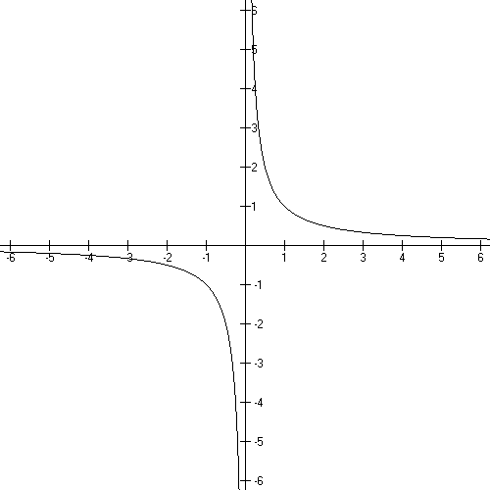
$$f(x)=\frac{1}{x}=x^{−1}$$

Domain: $(−∞,0)∪(0,∞)$
Range: $(−∞,0)∪(0,∞)$
x intercept: none
y intercept: none
vertical asymptote: x = 0
horizontal asymptote: y = 0

Decreasing on it’s domain

This function is one-to-one.

Example of a shifted graph:

- shifting instructions: left 2, down 3

- new formula:

We’ll track on (0, 0) which is the intersection of the
asymptotes and NOT a graph point for shifting.
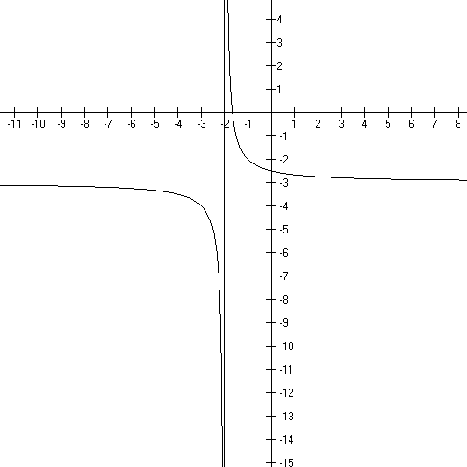

vertical asymptote: x = −2
horizontal asymptote y = −3

Domain: $(−∞,−2)∪(−2,∞)$

Range: $(−∞\text{.}−3)∪(−3,∞)$

x intercept: (−5/3, 0)

y intercept: (0, −5/2)

decreasing on it’s domain

Popper 05, Question 1

More discussion on Asymptotes:

The disallowed values in the domain create vertical asymptotes….x = 0 is a vertical asymptote for this graph…the unattainable values in the range create horizontal asymptotes…y = 0 is a horizontal asymptote.

Asymptotes are lines that shape the graph. Graphs cannot cross a vertical asymptote – these create branches − but sometimes cross horizontal asymptotes… the graph resembles a horizontal line for x’s far down either end of the x axis when there’s a horizontal asymptote.

Let’s look at f(x) = $\frac{3x+7}{x+2}$

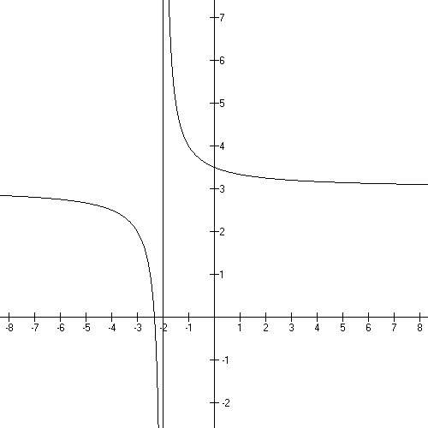

Domain:

Asymptotes:

VA

HA

What are the x and y intercepts?

VA:

Behavior at the VA: unbounded y values

HA: glb and lub for the y values

End Behavior:

Note that around (−2, 3) the graph does
NOT imitate the horizontal asymptotes
but far away from this point
it does look like these lines.

If you have a polynomial divided by a polynomial, you will have to identify and deal with all kinds of old ideas and new ideas…old ideas include x and y intercepts, the domain and range; new ideas are vertical and horizontal asymptotes and the behavior there plus holes.
Popper 05, Question 2

Vertical Asymptotes and Holes:

Linear factors in the denominator create vertical asymptotes unless they are cancelled with a like factor in the numerator…in which case, they create a hole. The domain determines which x values have problems and the formula determines which kind of problem it is.

Example: What’s the difference between

$f(x)=\frac{x^{2}−\text{26}}{x+5}$ and $f(x)=\frac{x^{2}−\text{25}}{x+5}$

Well, x + 5 cancels out of the second function and not out of the first.

The first graph has a vertical asymptote at x = −5 … a vertical asymptote at the disallowed value, ie the point we leave OUT of the domain…

the second function has only a hole there….(recall cancellation creates a hole at x = −5)

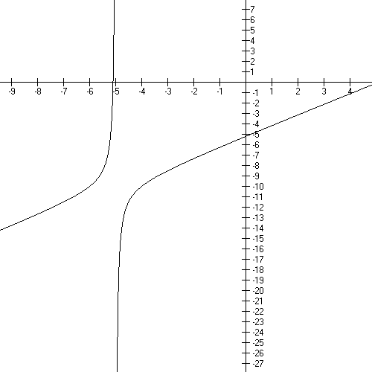

The first function
$$f(x)=\frac{x^{2}−\text{26}}{x+5}$$

End Behavior at the VA:

This graph has 2 branches arranged beside a vertical asymptote

And the second function – do the simplifying division and look at it again
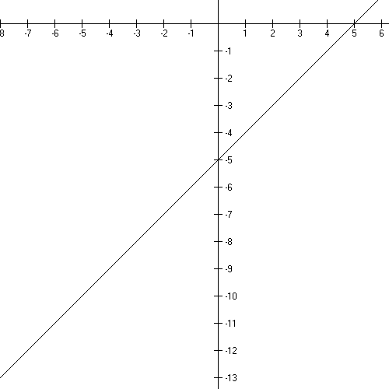

(−5, −10) is
missing from
D and R

This graph looks like f (x) = x + 5 with a hole at (−5, −10).

How did I know that the y–value was −10?

So when you have linear factors in the denominator you get a vertical asymptote or a hole. You get a
- vertical asymptote when it doesn’t cancel and a
- hole when it does cancel.

Popper 05, Question 3

Popper 05, Question 4

Now let’s review at Horizontal Asymptotes:

Basically you work off the leading terms. Divide the power of x in the numerator by the power of x in the denominator. See my handout on the website for more information and practice.

answer > 1 no horizontal asymptote

answer = 1 ha is ratio of coefficients n/d

answer < 1 x axis is horizontal asymptote

What is the HA for

What is the HA for

What is the HA for

Popper 05, Question 5

Popper 05, Question 6

Let’s look at some functions and tell what’s going on:

$f(x)=\frac{x^{2}−x−2}{x^{2}−1}$=

[parabola over a parabola!]

Domain:

Vertical asymptotes:

Holes:

HA

Range:

x intercepts

y intercept

Sign chart
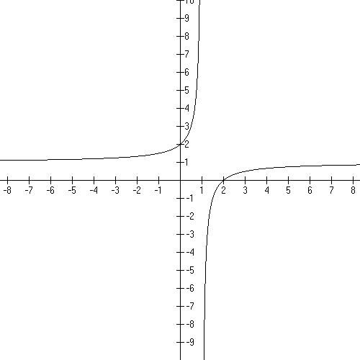

Graph:

End Behavior:

Behavior at the VA:

Behavior at the HA

Another one: =

Domain:

Vertical asymptote:

Holes:

HA

Range:
Note crossing of HA!

x intercepts

y intercept

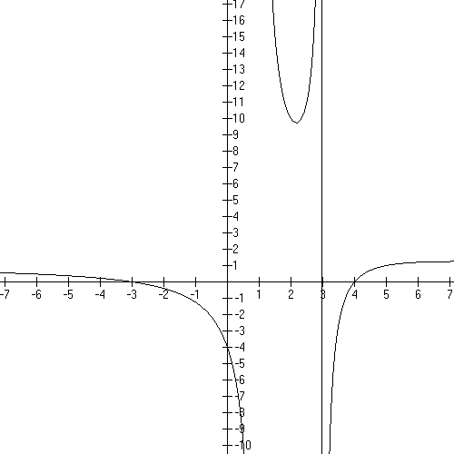
Graph

End behavior:

Behavior around the
asymptotes:

Note: crosses HA!
Let’s look more closely at rational functions that cross their horizontal asymptotes.

It is possible to tell that this happens WITHOUT graphing. Let’s first use the preceding function:

At the HA y = 1 and what is the y-value of a point on this asymptote?

Set up the equation and solve for x.

Now let’s try some others:

Where is the HA? What is the y-value of a point on the HA?

Set up the equation and solve

line/line form!

Where is the HA? What is the y-value of a point on the HA?

Set up the equation and solve

Where is the HA? What is the y-value of a point on the HA?

Set up the equation and solve

Where is the HA? What is the y-value of a point on the HA?

Set up the equation and solve

Popper 05, Question 7

Let’s look at a deceptively simple one:

$f(x)=\frac{3}{x+5}$ This IS a line over line. “SEE”
It doesn’t cross it’s HA!

Domain

VA

Holes

HA

Range

x intercepts

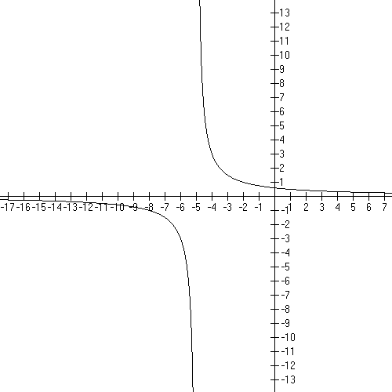
y intercept

graph

End behavior:

Behavior near asymptotes:

Popper 05, Question 8

Hints and Summaries

Zeros for the function are the zeros for the numerator after cancellation. x-axis intercepts are sometimes called “zeros of the function” because y is zero there.

For example: What is the x-intercept for the following function?

There’s the LONG way or the SHORT way to do this!

VAs come from the zeros in the denominator after cancellation. The VA is at the additive inverse of the number in the factor.
Factors that cancel from the denominator create holes in the graph at the additive inverse of the number in the factor.

For example:

HA. A function MAY cross it’s HA. Line/line graphs NEVER cross their HA (really!) and this makes for a restricted RANGE for these.

- n/d > 1 none

Domain

y-intercept

HA

- n/d = 1 ratio of coefficients

Domain

y-intercept

HA

- n/d < 1 x axis, y = 0

Domain

y-intercept

HA
Popper 05, Question 9

Tell me everything about $f(x)=\frac{x+6}{x−2}$ and sketch the graph.

Rational function of the line/line type.

Domain

VA

HA

Range

Intercepts:

x x + 6 = 0

y f (0)

Graph:

Popper 05, Question 10

End Video 2

Polynomials

A polynomial in x has one or more terms with a rational number coefficient and natural number power.

In the etexts: Math 1310, College Algebra (4.1 and 4.3)
Math 1330, Pre-calculus (2.2)

Term: math expressions that are added
Factor: math expressions that are multiplied

EXAMPLES: list leading term and constant term!

a. $f(x)$= 3 = $3x^{0}$

b. $f(x)=x^{2}+5x+4=x^{2}+5x+4x^{0}=(x+4)(x+1)$

c.

d. $f(x)=−x^{7}−\text{49}x=−x^{7}−\text{49}x+0x^{0}$

Samples of equations that are NOT polynomials:

Back to Polynomials:

The domain for every polynomial is all Real numbers. Always.

The y-intercept of the graph is f (0)…which is always the constant term (the term that
has the in it). Give the y-intercept of the polynomials in the example above:

The x-intercepts happen when the y value is zero. Replace f (x) with zero and solve for x. This always involves factoring. Note that the “zero” is the opposite sign of the
number in the factor. Give the x-intercepts of the examples above.

Give the intercepts for:

Behavior at the ends of the graph of a polynomial:

The Leading Term is ${\text{ax}}^{n}$. The Leading Coefficient, a, can be negative or positive and it gives you graphing information. The Leading Power, n, can be even or odd and it gives you graphing information. The graphing information is about the ends of the graph way away from the origin.

Here’s a table of that information:

Graphing  Chart - Ends | n is even | n is odd
a is positive | $↑↑$
a is negative | $↓↓$

Mnemonic: + even
+ odd

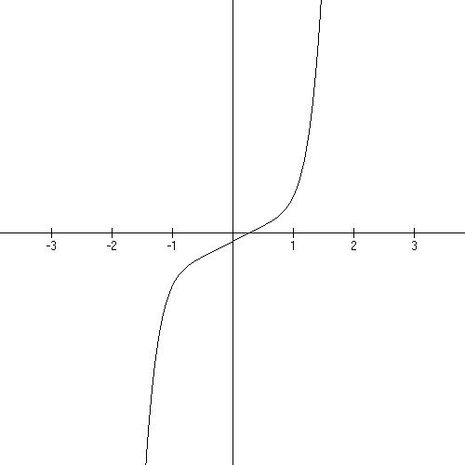
EXAMPLE 1: $f(x)=5x^{7}+\text{11}x−3$

Leading term:

5 is the leading coefficient
7 is the leading power

Domain: All Real numbers

y-intercept: −3 as in (0, −3), the constant term

Ends: a is positive, n is odd:

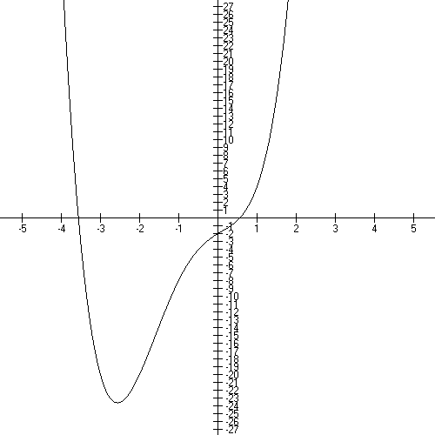
EXAMPLE 2:

$$f(x)=x^{4}+3x^{3}−x^{2}+3x−2$$

Leading coefficient: 1
Leading power: 4
Constant term: −2

Domain: all Real numbers

y-intercept: (0,−2)

Ends: a is positive, n is even $↑↑$

Popper 06, Question 1

x-intercepts

Note that both of the graphs above have x-intercepts. You find these by setting the polynomial to zero (y is always zero at an x-intercept) and factoring the polynomial to find the intercepts (aka: zeros).

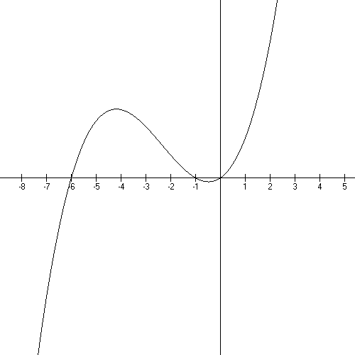
EXAMPLE 3: $f(x)=x^{3}+7x^{2}+6x$

Leading coefficient: 1
Leading power: 3
(+, odd) =
Constant term: 0

Domain: all Real numbers

y-intercept: (0, 0)
f (0)!

Ends: positive, odd

x-intercepts:

$$\begin{aligned}0=x^{3}+7x^{2}+6x \\ 0=x (x^{2}+7x+6) \\ 0=x (x+6)(x+1) \\ x=0, x=−6, \text{or} x=−1\end{aligned}$$

Popper 06, Question 2

Behavior at x-intercepts:

In example 3 above, the graph goes through each intercept locally just like a line. That happens because the exponent on each factor is 1.
Let’s look at the formula and graph more closely:

“Local” – tiny circle

The exponents on the factors tell you the local behavior of the graph at an intercept.

exponent is 1 graph goes through like a line

(x – 1)

exponent is 2 graph curves back tangent to the x-axis like a parabola

(x – 1)²

exponent is 3 graph squiggles through the point like x-cubed

(x – 1)³
Popper 06, Question 3

EXAMPLE 4:

Domain: all Real numbers

Leading term: x⁶

^{Leading coefficient:} ¹
Ends: (+, even) = $↑↑$

y-intercept: 1³(−2)²(−3)¹= −12 use the last number in each factor
constant term!
f (0)

x-intercepts: −1 squiggle (x + 1)³
2 parabola (x – 2)²
3 line (x – 3)¹

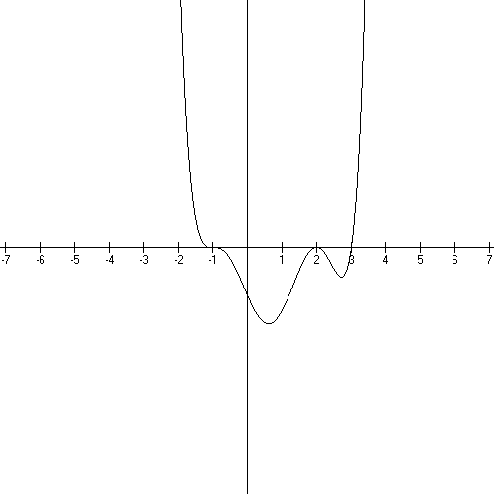

Popper 06, Question 4

Working backwards from the graph to the equation

EXAMPLE 5:

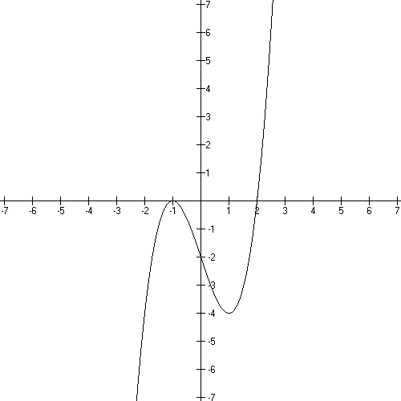
Leading term is positive and leading exponent is odd!

−1 is an x-intercept and
the graph is locally like a parabola there
so the power on the factor is 2:

2 is an x-intercept and the
graph is locally like a line there so the power
on the factor is 1.

$$f(x)=(x+1)^{2}(x−2)$$

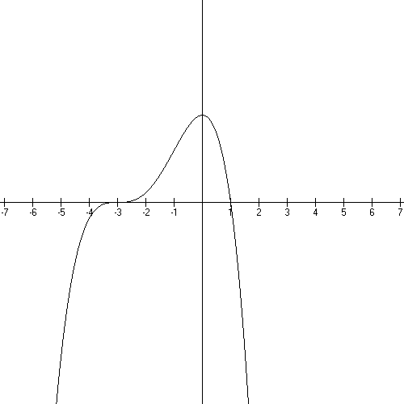
EXAMPLE 6:

Leading term is negative
and even

at −3 the graph is a squiggle…
the power on the factor is 3
at 1 the graph is a line so the
power on the factor is 1

$$f(x)=−(x+3)^{3}(x−1)$$

Popper 06, Question 5

Sequences*

a good source:
*Cohen, David Precalculus, 5th edition West Publishing isbn 0-314-06921-6

A numerical sequence is a function with a domain of the natural numbers. A single element of the range is called a term of the sequence. Some sequences are finite – the number of terms is a given natural number – and some are infinite.

Very often the terms are indexed by the natural numbers…the indices are the domain numbers.

EXAMPLE 1: A sequence with a formula

The SUBSCRIPTS are actually the domain elements.

a₁ gives the point (1, ½). The subscript is the first coordinate!

This is an infinite sequence bounded below by ½ , which is a function point and above by 1 which is not. Each is a y-value and each n is the associated x.

[Sometimes the function has the whole numbers as it’s domain and the indexing starts with 0.]

Let’s write this sequence as point pairs and then graph them in 2 dimensions.
Show where the bounds are and label those.
Write out the domain and range in words. Is this a function? How do you know?

EXAMPLE 2:

What are the point pairs? Are there bounds? What is the domain and range (in words)?
Is this a function? How do you know?

Popper 06, Question 6

Recursive sequences

Sometimes, the next term in a sequence is defined by a preceding term or two, these are called recursive sequences.

Note that the formula shows t”next” in terms of the preceding t

t”next” is

t preceding is

Let’s calculate the second and third t’s:

The sequence is: 3, 4, 6, 10, 18, 34, 66, 130, 258, 514

These are range elements.
The domain elements are given in the inequality above.
This is a finite sequence.

Write the point pairs, graph and discuss bounds.

The Fibonacci sequence is an example of an infinite recursive sequence.

Popper 06, Question 7

Arithmetic Sequences

If you begin your sequence with a given number and then add a fixed number to each succeeding term, then you’ve made an arithmetic sequence.

These sequences are generally written as (a, d).
The pattern is: a is given as the first term and d will be what is added to each succeeding term:

a, a + d, a + 2d, a + 3d, a + 4d, …

The pattern allows us to come up with a formula for the nth term:

Distribute the “d” above

EXAMPLE 4

Given the arithmetic sequence: 7, 10, 13, 16, ….
What is the 100th term?

a = 7 d = 3

List point pairs, graph, discuss domain, range and bounds.

7, 10, 13, 16, ….

Domain: the natural numbers

Range: a proper subset of the natural numbers = { 7, 10, 13, 16, 19, …}

Point pairs: (1, 7), (2, 10), (3, 13), (4, 16), (5, 19)…(n, ), …

Checking: a = 7 d = 3

(4, 3(4) + 7 – 3) = 16)

Graph:

Is it a function? Does it pass the vertical line test?

Is it bounded below? Above?

Popper 06, Question 8

EXAMPLE 5

Give the details of the arithmetic sequence with a second term of −2
and an eighth term of 40.

is the general formula

I know

−2= a + (2−1)d and 40 = a + (8−1)d

So I can get a and d.

−2 = a + d
40 = a + 7d

multiply the second equation by −1…add them….−42 = −6d so d = 7 and a = −9.

This is all we need to specify to give the details.

List the point pairs, graph and discuss domain, range, and bounds.
Is it a function? How do you know?

Popper 06, Question 9

Geometric Sequences

A geometric sequence is a sequence of the form:

Note that the first term is really: If you see it this way you can see the pattern

The nth term is then:

Notice, too, where the “n”’s are in this formula! And that we’re using whole numbers as exponents, but natural numbers to count the terms of the sequence!

EXAMPLE 6

1, ½, ¼, 1/8, …, what are a and r?

What are the domain elements?

What are the point pairs?

Graph in 2D and discuss boundaries!

EXAMPLE 7

10, −100, 1000, −10,000 … what are a and r?

What are the point pairs?

These graph as points in the plane. Discuss bounds.

Popper 06, Question 10

End Video 3

